**Project report**

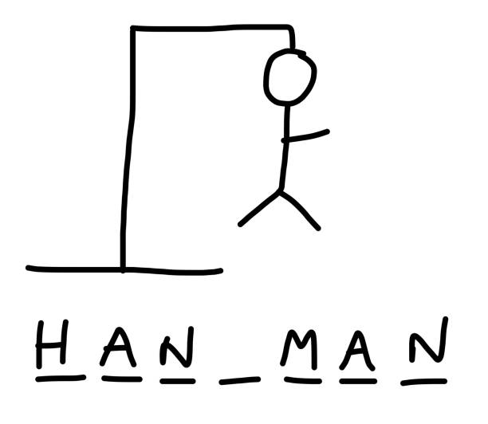

**HANGMAN**

**TEAM MEMBERS: SUBMITTED TO:  
MUHAMMAD WALEED K240772 MS. KHADIJA TUL QUBRA  
MUHAMMAD AYAAN K240626  
MUHAMMAD HANEEF K241019  
BCS – 1E**

Introduction:

Some introductions here answering:   
What is your Project?  
What does it do?  
Why did you choose it?

* The project is based on a famous word guessing game known as hangman. It’s very simple the user guesses the entire word letter by letter until it is fully guesses. Upon wrong guesses the hangman starts to appear in parts and bringing the game to an end when it fully appears on the screen. In our project we have setup 4 different categories of food, animal, countries and sports each with 25 words summing up to total of 100 words. After the user select his desired category to play from, a timer of 20 seconds will start, and user must guess as many correct answers as possible. In the end, user score will be displayed in the form of number of correct and wrong guesses. The reason we choose this game was just because it was simple and not so much complex and our all group member agreed to choose this topic.

Design & Implementation:

Write Pseudocode and Draw your flowcharts.

Pseudocode:

* Users select category from food, countries, food , sports from number 1 to 4. 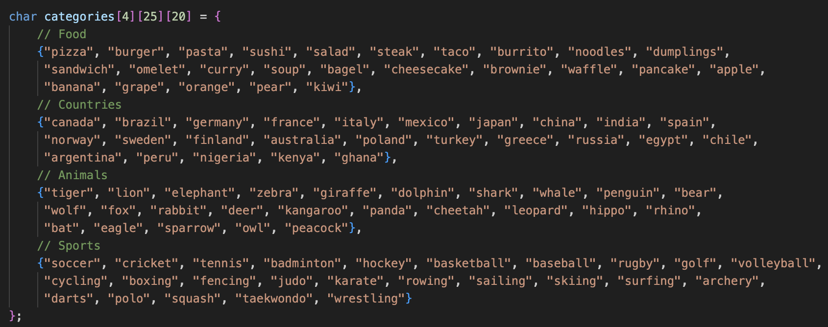
* users have 20 seconds to play game.
* User guesses letter if the guess is wrong the hangman appears and game end if hangman fully appears. The hangman is built using the the counter to count the wrong guesses and later using switch to print it. The number represent the number of wrong guesses.  
  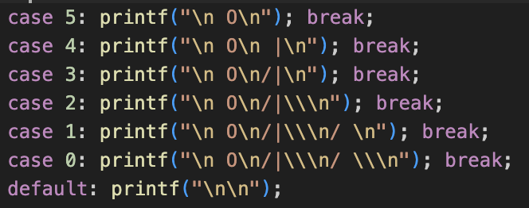
* If the user makes a guess the code loops around the word and check whether the letter is present in the word or not.

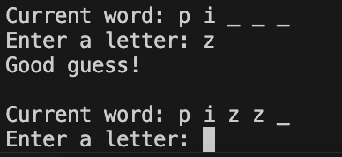

* If the user guesses the entire word correctly and it matches to word in array then score increase by 1 and player proceeds to next word. And it keeps on moving until the time is up.

Flowcharts(general):   
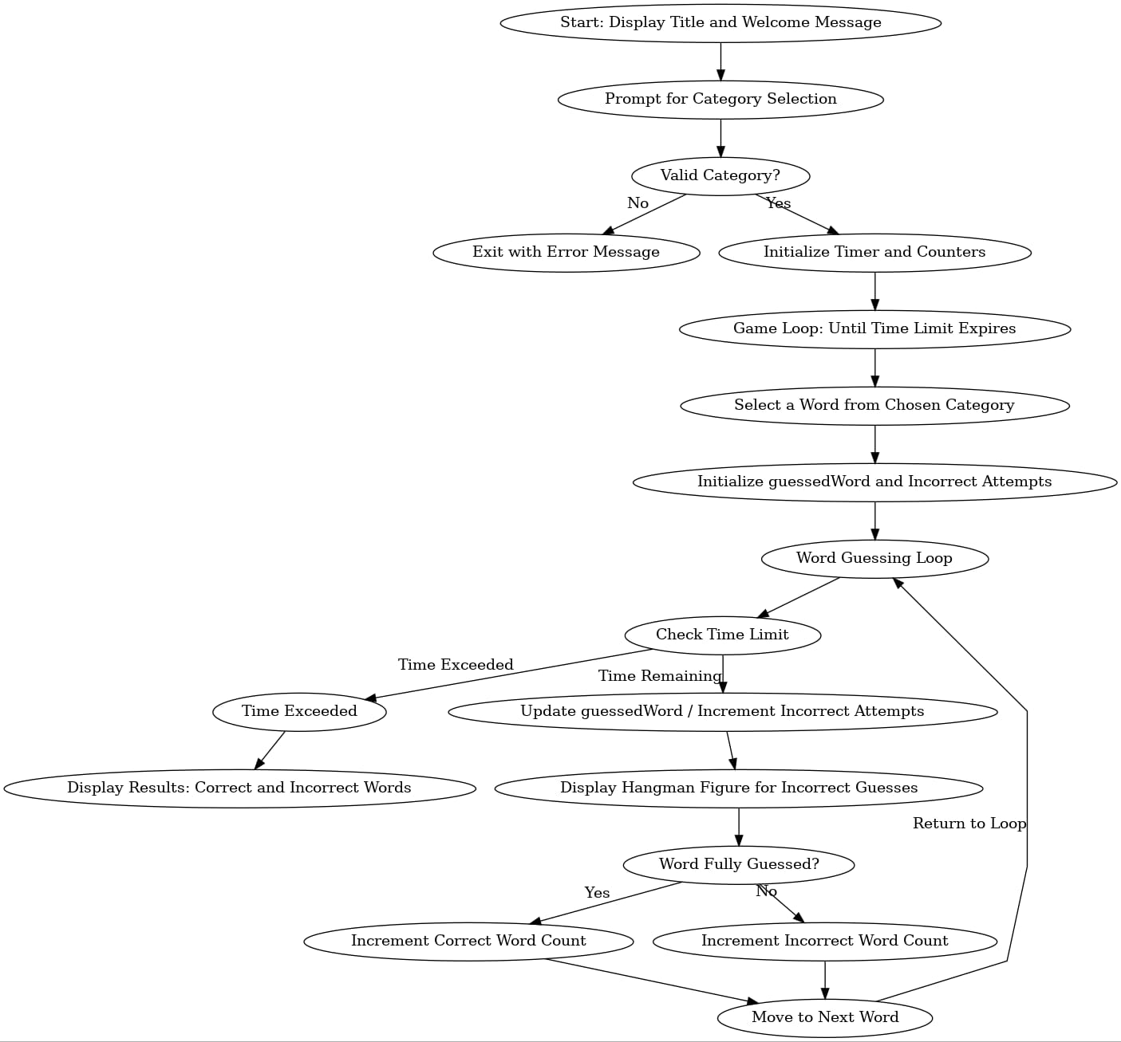

Word guessing loop flowchart:

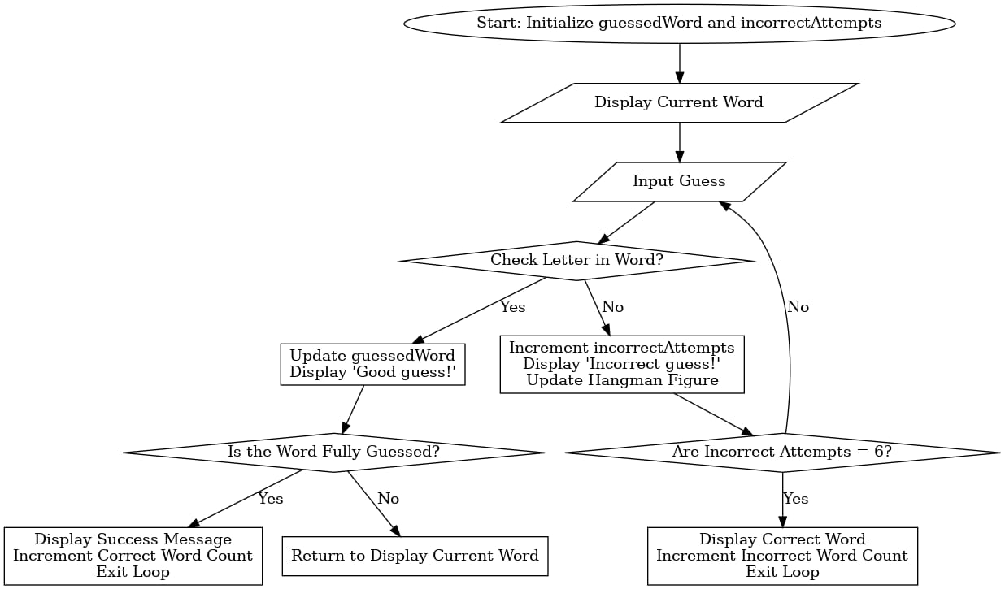

word

Results:

* When the code is run the user sees a list of number to press to choose the category.

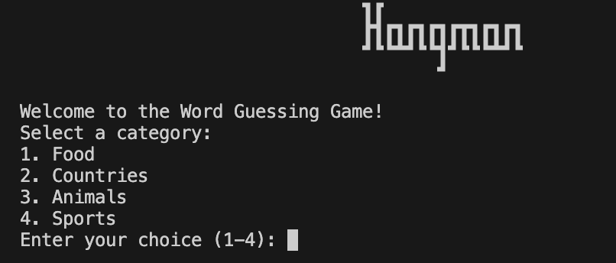

* The user chooses from the option and game starts. User guesses the word letter by letter.

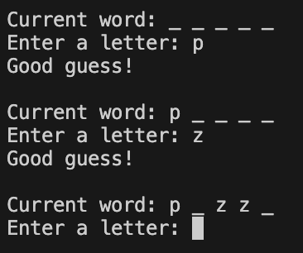

* When input wrong letter player hangman starts to appear.

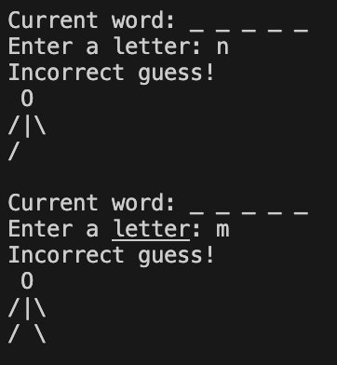

* If the users guessed the word correctly program congratulates him moves to next word.

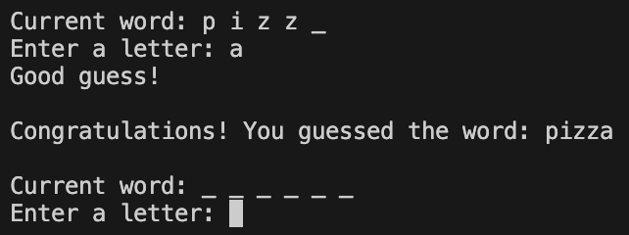

* It continues to move forward until time is up and in the it displays the score



THE END.

References:

<https://www.quora.com/How-can-I-write-a-simple-Hangman-game-in-C>

<https://www.mycompiler.io/view/HkKo1E5>

<https://www.tutorialspoint.com/c_standard_library/index.htm>